**CS402- Theory of Automata**

**Final Term Examination – Spring 2005**

**Time Allowed: 150 Minutes**

**[www.vuzs.net/](http://www.vuzs.net/)**

Instructions

**Please read the following instructions carefully before attempting any question:**

1. **This examination is closed book, closed notes, closed neighbors.**
2. **Answer all questions.** 
   1. **There is no choice.**
   2. **You will have to answer correctly all questions in this examination to get the maximum possible marks.**
3. **Do not ask any questions about the contents of this examination from anyone.** 
   1. **If you think that there is something wrong with any of the questions, attempt it to the best of your understanding.**
   2. **If you believe that some essential piece of information is missing, make an appropriate assumption and use it to solve the problem.**
4. **You are allowed to use any Software for Diagrams and Symbols like MS Word, MathType and Visio etc.**

**\*\*WARNING: Please note that Virtual University takes serious note of unfair means. Anyone found involved in cheating will get an `F` grade in this course.**

|  |  |  |
| --- | --- | --- |
| **Total Marks: 50** | | **Total Questions: 09** |
|  | |  |
| **Question No. 1** | | **Marks : 02** |
| **A Total Language Tree has** | |  |
| **o** | All languages over Σ |  |
| **o** | All strings over Σ |  |
| **o** | All words of all languages over Σ |  |



**o** All words of one language overΣ



|  |  |  |  |  |  |  |
| --- | --- | --- | --- | --- | --- | --- |
| **Question No. 2** |  |  |  |  | **Marks : 10** |  |
| **(a) Derive any two words of length 4 from the following CFG.** | | | | |  |  |
| **S**→**XaaX, X**→**aX|bX|****.** | | |  |  |  |  |
| **Write the corresponding RE as Well.** | | |  |  | **(5)** |  |
| **(b) Determine the CFG, corresponding to the following FA** | | | |  | **(5)** |  |
|  | a |  | b | b |  |  |
|  |  |  |  |  |
|  |  |  |  |  |  |
|  | a | A | a | C+ |  |  |
|  |  |  |  |
|  |  |  |  |  |
|  |  |  |  |  |  |
| S– | b |  | a | a |  |  |
|  |  |  |  |
|  |  |  |  |  |
|  | b |  |  |  |  |
|  | B |  | D+ |  |  |
|  |  | b |  |  |
|  |  |  |  |  |
|  |  |  |  |  |  |
| **Question No. 3** |  |  |  |  | **Marks : 02** |  |
| **What Turing Machine does not have?** | |  |  |  |  |  |

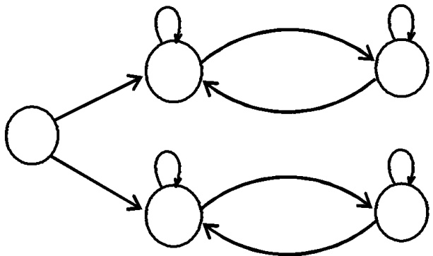

**o o o o**

Stack

Tape

Head

Word



|  |  |  |  |  |  |
| --- | --- | --- | --- | --- | --- |
| **Question No. 4** |  |  |  | **Marks : 10** |  |
| **(a) Draw Moore Machine equivalent to following Mealy Machine.** | | | | **(5)** |  |
| 1/0 | q1 | 1/1 |  |  |  |
|  |  |  |  |
|  |  |  |  |  |
|  |  | 0/0 |  |  |  |
| q0 | 0/1 | q3 | 1/0 |  |  |
|  |  |  |  |
|  |  |  |  |  |

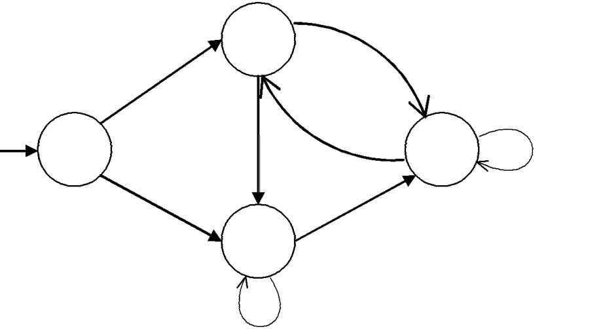

|  |  |
| --- | --- |
| 0/0 | 1/0 |
|  | q2 |
|  | 0/1 |

|  |  |  |  |  |  |
| --- | --- | --- | --- | --- | --- |
| **(b) Use Pumping Lemma II to show that following language is non-regular.** | | | | **(5)** |  |
|  | **Square (** *a* | *n* | 2 |  |  |
| **i.** | **, for n = 1, 2, 3, ….)** |  |  |
|  |  |  |
|  | |  |  |  |  |
| **Question No. 5** | |  |  | **Marks : 10** |  |



**Identify the language accepted by the following PDA. Build an FA accepting the corresponding language. Write the corresponding RE as well.**

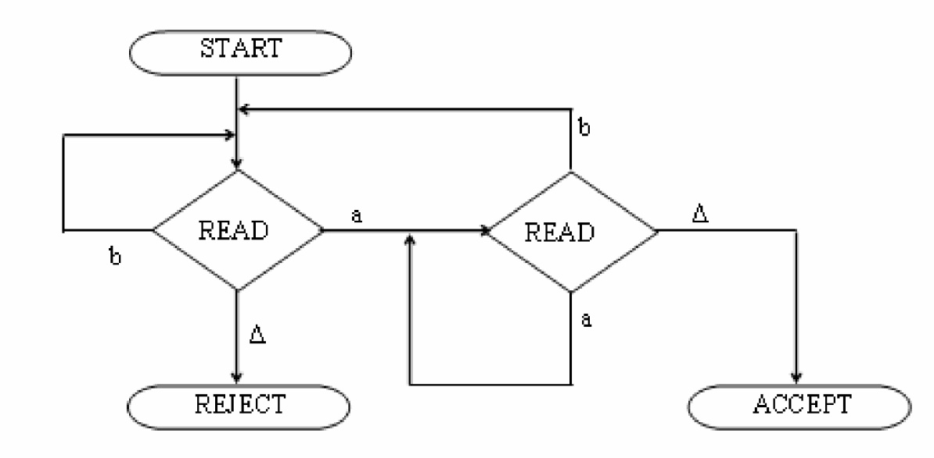

|  |  |  |
| --- | --- | --- |
| **Question No. 6** | | **Marks : 02** |
| **Two FAs represent same languages over some alphabet (may or may not be same for** | | |
| **FAs), If** |  |  |
|  | **o** | They accept same words |
|  | **o** They accept same number of words | |
|  | **o** | They reject same words |
|  | **o** | None of above |
|  | |  |
| **Question No. 7** | | **Marks : 02** |
| **CFG given S**  **bS|Sb|aa represents language** | | |
| **o** | b*aa | |
| **o** | aab* | |
| **o** | b*aab* | |
| **o** | b*(aa)*b* | |
|  | |  |
| **Question No. 8** | | **Marks : 10** |



**a) Define the following terms**

**(6)**

1. **Total language tree (TLT)**
2. **Ambiguous CFG.** 
   1. **Unit Production**
3. **Find Context Free Grammar's (CFG's) for the following languages over the** Σ**={a, b}.**

**(4)**

1. **All the words that do not contain substring abb.**
2. **All the words that have exactly two or three b's.**



**Question No. 9** **Marks : 02**

**A Language that is finite but not regular**

**o o o**

Λ

(a+b)*

Φ

**o** All strings of a's inΣ **=** {a,.b}